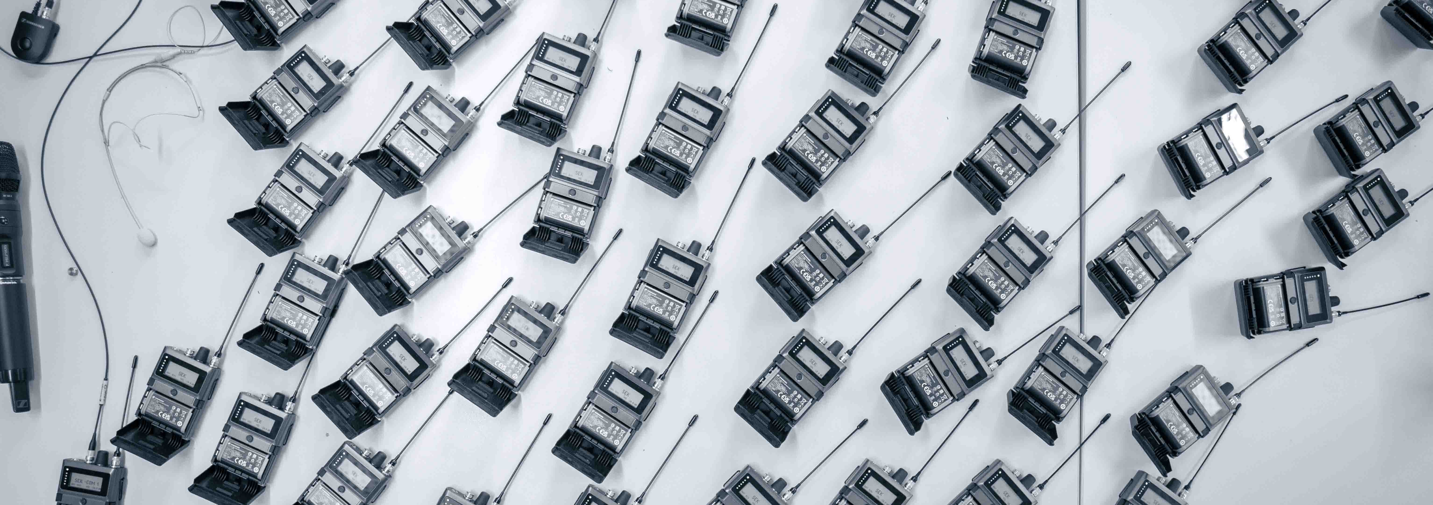

Planning the biggest Spectera deployment to date
Agorà and Sennheiser get ready to work with host broadcaster ORF during the Eurovision Song Contest in Vienna

Wedemark (D)/Bazzano (IT), April 2026 – The doors of the spacious project area at Sennheiser’s head office opened, revealing large screens displaying control software, and an impressive set-up of mobile and stationary wireless audio devices under endurance testing. Here, experts from Agorà and Sennheiser met to discuss the audio installation for the upcoming Eurovision Song Contest (ESC). Both Agorà and Sennheiser are official audio suppliers to the ORF for the ESC, with Agorà handling technical production for the event.

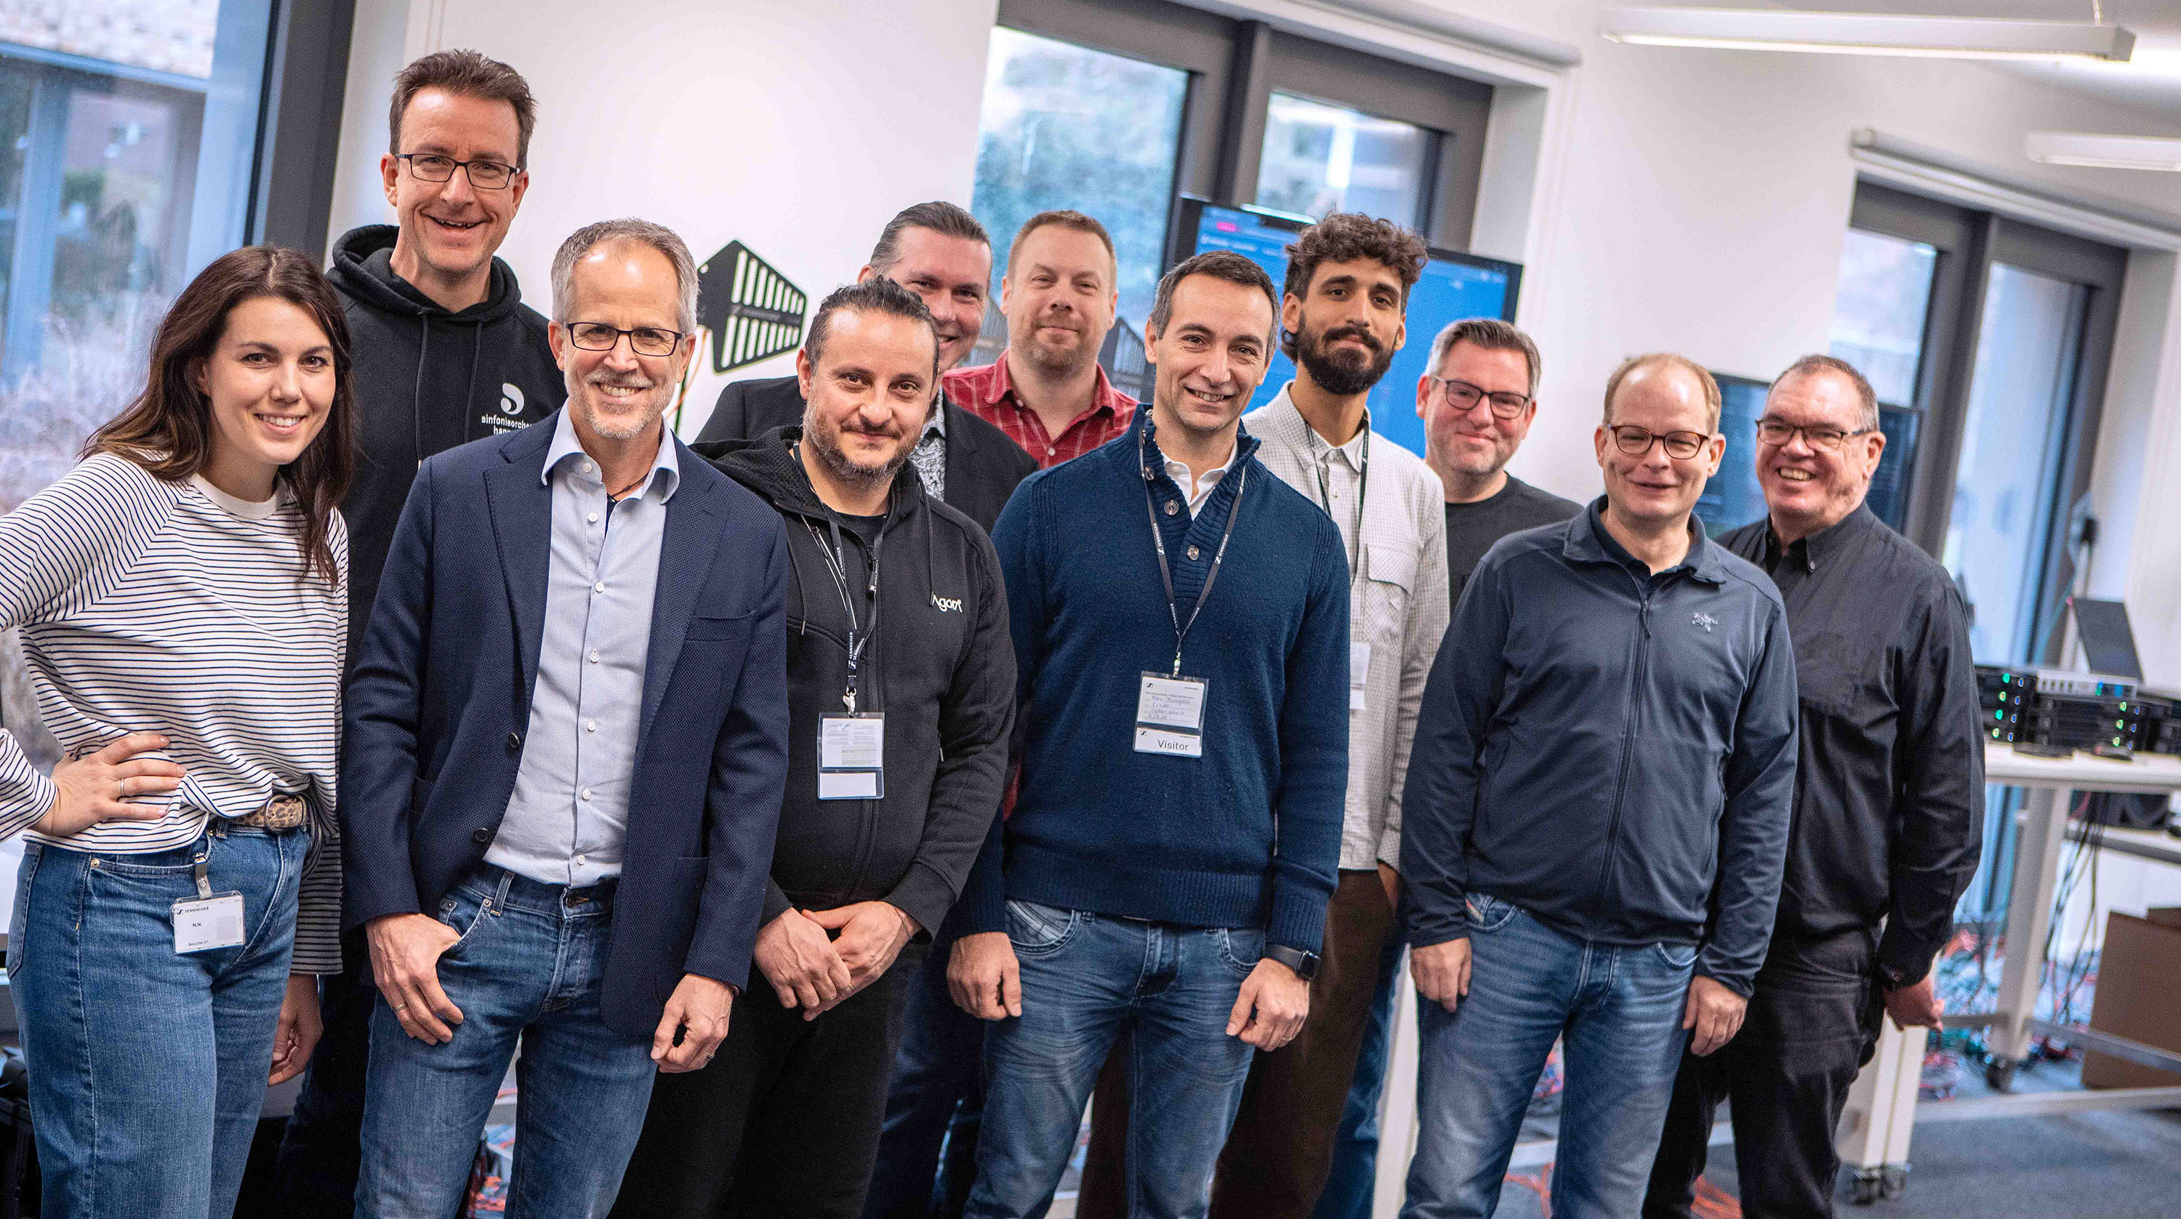
Meeting in Wedemark (l-r): Corinna Trojan (Sales Director Country Partners EMEA), Sebastian Georgi (Senior Development Engineer Transmission Technology), CEO Dr Andreas Sennheiser, Domenico Cerqua (Head of Audio & Light at Agorà), Jérôme Zastrow (Senior Digital Business Modelling Manager), Jonas Næsby (Technical Application Engineer), Fabio Fumagalli (Sennheiser Partner Exhibo), Valerio Motta (Project Lead ESC at Agorà), Jan Watermann (Senior System Architect), Kevin Jungk (Solution Architect), Volker Schmitt (Manager Technical Application Engineering)

This will be the fourth time at the ESC for leading Italian rental company, Agorà. In Lisbon and Tel Aviv, they supported the local teams for PA, RF, show mixing and network technology. In Turin, they were in charge themselves, and are now bringing the same full service to host broadcaster ORF in Vienna.

Valerio Motta, Agorà’s project manager for the ESC 2026, is excited to see the great advances in technology and workflow that this mega-broadcast brings year after year. “But the best part of the job,” he says, “is to work with teams from so many nations. The ESC is like a very fast and complex festival – we love it!”

Dr Andreas Sennheiser highlights the technical aspect: “The Eurovision Song Contest is a huge opportunity for companies to put their latest and greatest technology through its paces at the world’s biggest live music broadcast. We’re very pleased to be able to partner with the ORF and very happy to have welcomed Agorà to the Sennheiser offices.”

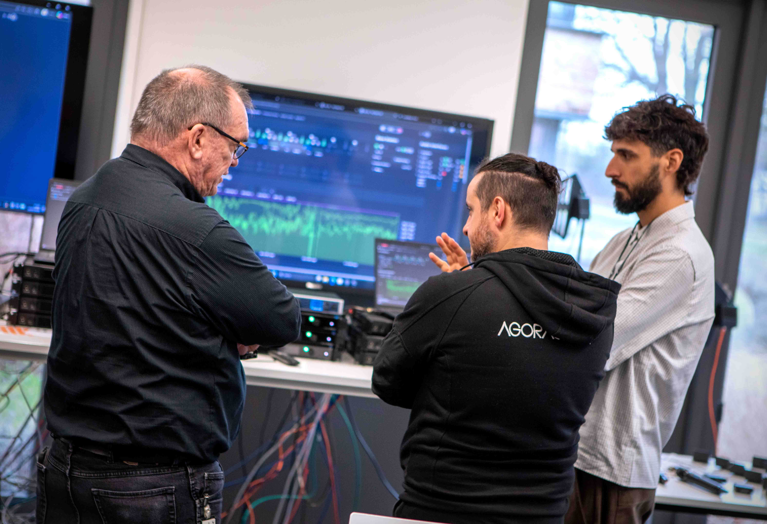 | Volker Schmitt (l) in conversation with Domenico Cerqua and Valerio Motta (r) from Agorà. In the background: the level recorder implemented for ESC

For the Eurovision Song Contest, Sennheiser will deliver their largest Spectera set-up to date, including manufacturing samples of the yet to be launched handheld transmitter. A firmware variant especially for the event adds functionalities that will be needed on site, such as a level recorder. Volker Schmitt, Manager Technical Application Engineering and ESC veteran, says: “We’re excited to bring the largest deployment worldwide of Spectera Base Stations, bidirectional bodypacks and handheld mics to the ESC. Artists and crews will benefit from the extraordinary clarity of IEMs over Spectera, and artists using a headset mic will be able to perform with just one belt pack. Like the Agorà team, our wireless experts are very much looking forward to the amazing international teamwork at the ESC.”

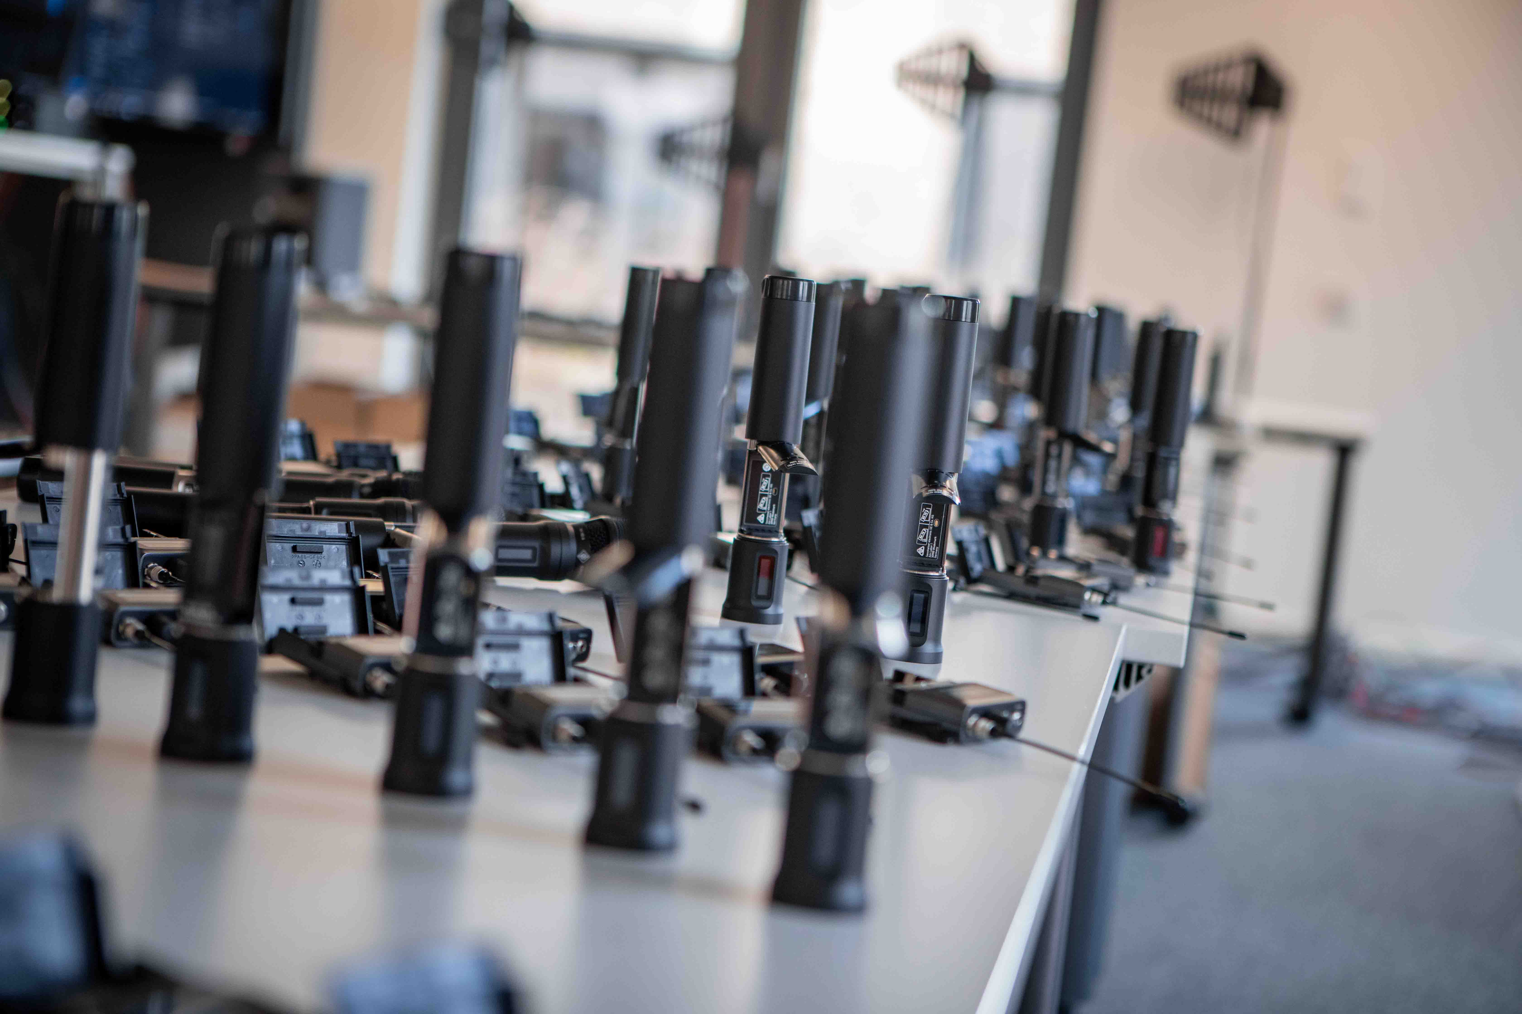 | The upcoming Spectera handhelds garnered some attention

After the endurance test at Sennheiser, all Spectera devices were shipped to Agorà for further tests and configuration into racks, followed by a two-day Spectera training at Agorà’s headquarters. The Agorà and Sennheiser teams are all getting ready to support host broadcaster ORF in its task to make the world’s biggest live music contest a reality.

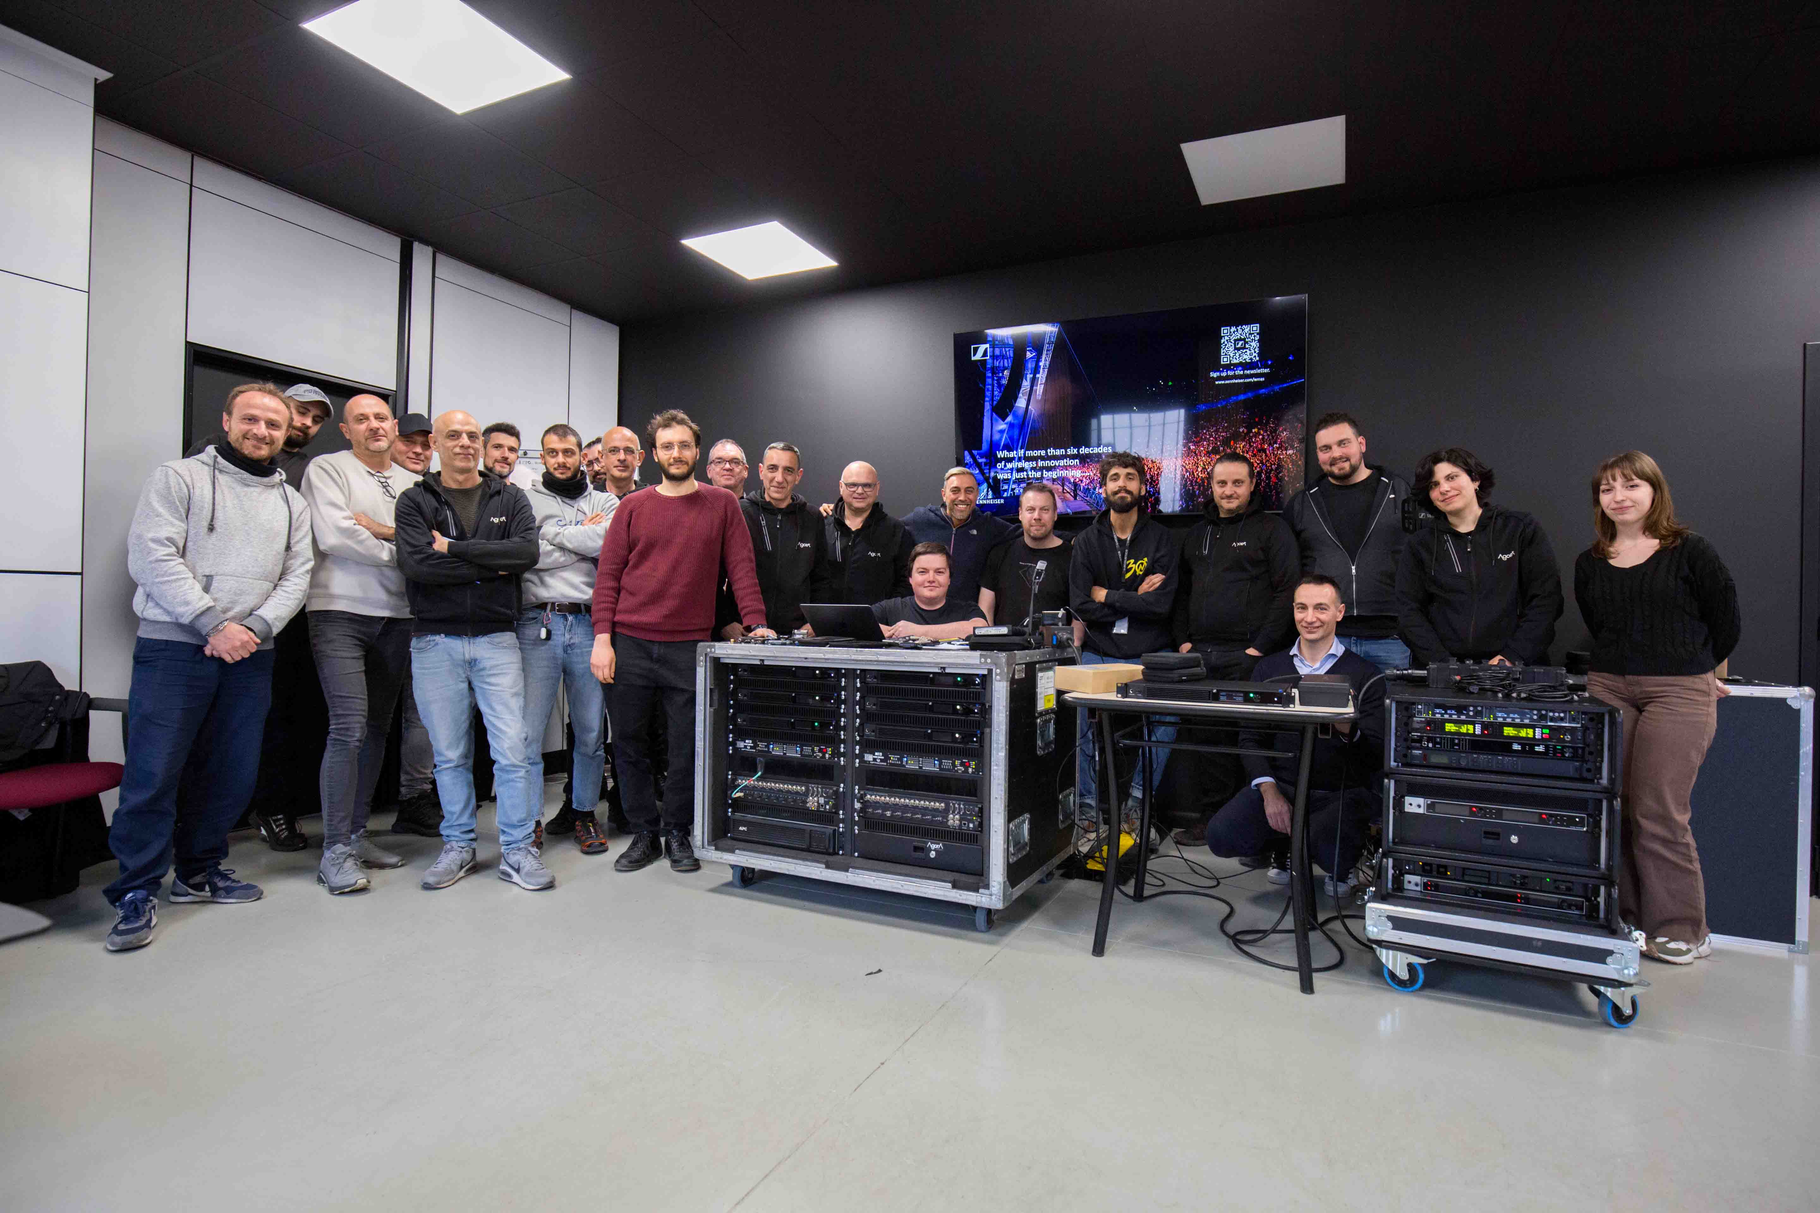
The Agorà team took a deep dive on wideband technology and Spectera

(Ends)

The high-resolution images accompanying this media release and additional photos can be downloaded here.

About Agorà
Rome-based Agorà is a leading production company for the rental, supply and installation of lighting, audio, video graphics, rigging and structures for every kind of music, corporate, sport and mass event. Founded in 1990 by brothers Wolfango and Vittorio De Amicis, the company’s customer focus, high degree of customization and excellent quality of work have made it grow rapidly to one of today’s leading production companies in Italy and one of the largest in Europe.

About the Sennheiser brand
We live and breathe audio. We are driven by the passion to create audio solutions that make a difference. Building the future of audio and bringing remarkable sound experiences to our customers – this is what the Sennheiser brand has represented for 80 years. While professional audio solutions such as microphones, meeting solutions, streaming technologies and monitoring systems are part of the business of Sennheiser electronic SE & Co. KG, the business with consumer devices such as headphones, soundbars and speech-enhanced hearables is operated by Sonova Holding AG under the license of Sennheiser.

www.sennheiser.com
www.sennheiser-hearing.com

Global Pro Audio Press Contact
Stephanie Schmidt
stephanie.schmidt@sennheiser.com
+49 (5130) 600 – 1275

